**Question 1 Consider the combinational circuit shown in Fig**

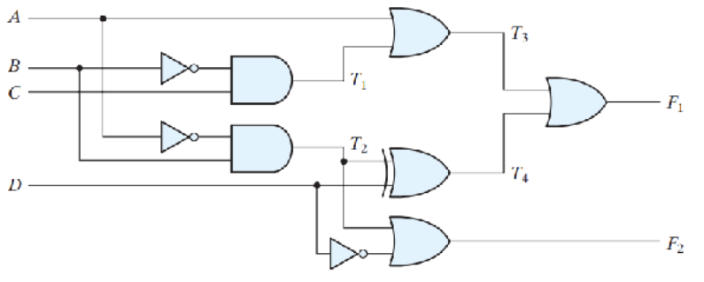



1. Derive the Boolean expressions for T1 through T4. Evaluate the outputs F1 and F2 as a function of the four inputs.
$$T_{1}=B^{'}C \\ T_{2}=A^{'}B \\ T_{3}=A+B^{'}C \\ T_{4}=A^{'}B ⊕D \\ F_{1}=T_{3}+T_{4}=\left(A+B^{'}C\right)+\left(A^{'}D⊕D\right) \\ F_{2}=T_{2}+D^{'}=A^{'}B+D^{'}$$

2. List the truth table with 16 binary combinations of the four input variables. Then list the binary values for T1 through T4 and outputs F1 and F2 in the table.

|  |  |  |  |  |  |  |  |  |  |  |  |  |  |  |
| --- | --- | --- | --- | --- | --- | --- | --- | --- | --- | --- | --- | --- | --- | --- |
| No | A | B | C | D | A’ | B’ | D’ | $$T_{1}$$ | $$T_{2}$$ | $$T_{3}$$ | | $$T_{4}$$ | $$F_{1}$$ | $$F_{2}$$ |
|  |
| 0 | 0 | 0 | 0 | 0 | 1 | 1 | 1 | 0 | 0 | 0 | 0 | | 0 | 1 |
| 1 | 0 | 0 | 0 | 1 | 1 | 1 | 0 | 0 | 0 | 0 | 1 | | 1 | 0 |
| 2 | 0 | 0 | 1 | 0 | 1 | 1 | 1 | 1 | 0 | 1 | 0 | | 1 | 1 |
| 3 | 0 | 0 | 1 | 1 | 1 | 1 | 0 | 1 | 0 | 1 | 1 | | 1 | 0 |
| 4 | 0 | 1 | 0 | 0 | 1 | 0 | 1 | 0 | 1 | 0 | 1 | | 1 | 1 |
| 5 | 0 | 1 | 0 | 1 | 1 | 0 | 0 | 0 | 1 | 0 | 0 | | 0 | 1 |
| 6 | 0 | 1 | 1 | 0 | 1 | 0 | 1 | 0 | 1 | 0 | 1 | | 1 | 1 |
| 7 | 0 | 1 | 1 | 1 | 1 | 0 | 0 | 0 | 1 | 0 | 0 | | 0 | 1 |
| 8 | 1 | 0 | 0 | 0 | 0 | 1 | 1 | 0 | 0 | 1 | 0 | | 1 | 1 |
| 9 | 1 | 0 | 0 | 1 | 0 | 1 | 0 | 0 | 0 | 1 | 1 | | 1 | 0 |
| 10 | 1 | 0 | 1 | 0 | 0 | 1 | 1 | 1 | 0 | 1 | 0 | | 1 | 1 |
| 11 | 1 | 0 | 1 | 1 | 0 | 1 | 0 | 1 | 0 | 1 | 1 | | 1 | 0 |
| 12 | 1 | 1 | 0 | 0 | 0 | 0 | 1 | 0 | 0 | 1 | 0 | | 1 | 1 |
| 13 | 1 | 1 | 0 | 1 | 0 | 0 | 0 | 0 | 0 | 1 | 1 | | 1 | 0 |
| 14 | 1 | 1 | 1 | 0 | 0 | 0 | 1 | 0 | 0 | 1 | 0 | | 1 | 1 |
| 15 | 1 | 1 | 1 | 1 | 0 | 0 | 0 | 0 | 0 | 1 | 1 | | 1 | 0 |

1. Plot the output Boolean functions obtained in part (b) on maps and show that the simplified Boolean expressions are equivalent to the ones obtained in part (a).

$$For the fucntion F_{1}$$

$$F_{1}\left(A, B,C,D\right) = \sum{m(1, 2, 3, 4, 6, 8, 9 , }10, 11, 12, 13, 14, 15)$$

|  |  |  |  |  |
| --- | --- | --- | --- | --- |
| CD  AB | 00 | 01 | 11 | 10 |
| 00 | 0 | 1 | 1 | 1 |
| 01 | 1 | 0 | 0 | 1 |
| 11 | 1 | 1 | 1 | 1 |
| 10 | 1 | 1 | 1 | 1 |



|  |  |  |  |  |
| --- | --- | --- | --- | --- |
| CD  AB | 00 | 01 | 11 | 10 |
| 00 | 1 | 0 | 0 | 1 |
| 01 | 1 | 1 | 1 | 1 |
| 11 | 1 | 0 | 0 | 1 |
| 10 | 1 | 0 | 0 | 1 |



$$F_{2}\left(A, B, C,D\right)=AB^{'}+D'$$

**Question 2 Obtain the simplified Boolean expressions for output F and G in terms of the input variables in the circuit of Fig.**



= **A’D’+ABC +BCD’**